CS385 – CPU Project

Robert Rotaru, Bryan Bigelow, Anthony Cerritelli

# Progress Report 1

## Tasks

**Template (16-bit)**

* CPU Template (16-bit) – Rob, Tony

**Extended ALU (16-bit)**

* 16-bit ALU – Rob
  + Testing – Rob
* Gate Level 4x1 and 2x1 Mux – Bryan
  + Testing – Bryan

**Register File (16-bit)**

* 16-bit Registers – Bryan, Tony
  + 16-bit Extension (Full) – Tony
  + 16-bit Flip-Flops - Bryan
  + Testing - Tony
* Gate Level 4x1 Mux – Bryan
  + Testing – Bryan

**Test Program (16-bit)**

* 16-Bit Translation – Bryan
* Testing – Tony, Rob

**Diagrams**

* Single-Cycle Path – Tony
* Internals - Bryan

**Report** - Robert Rotaru, Bryan Bigelow, Anthony Cerritelli

## Diagrams

**Registers**

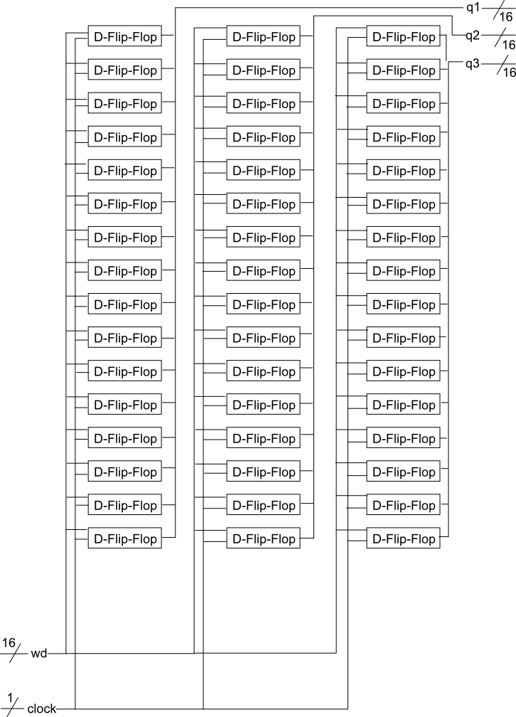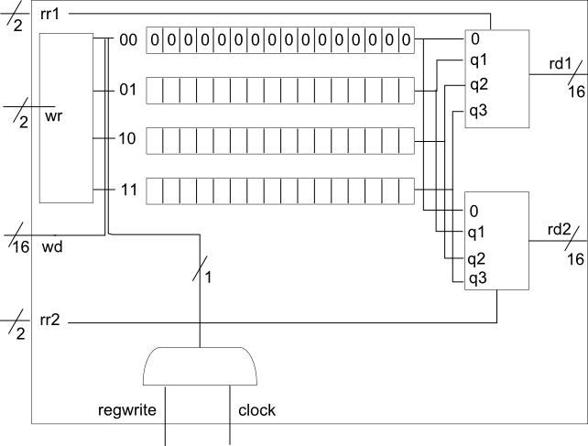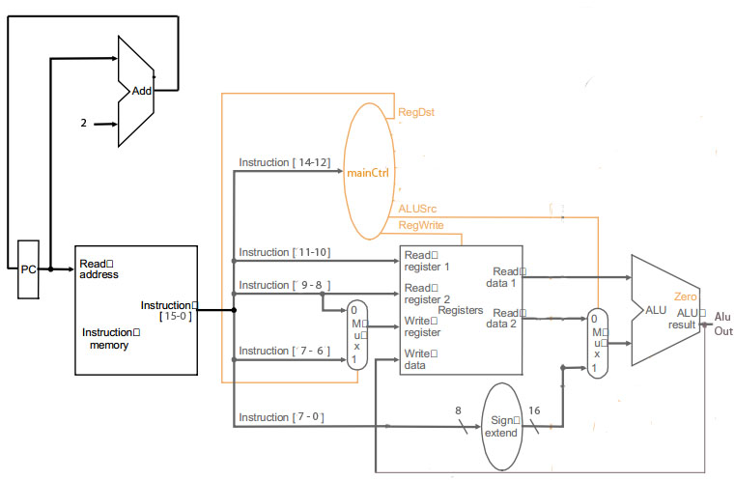

Single-Cycle Datapath

## Source Code

/* CS 385 - Semester Project - Progress Report 1

Authors:

Robert Rotaru

Bryan Bigelow

Anthony Cerritelli

Content:

16-bit MIPS CPU in Verilog

All source code and project work can be found on GitHub at:

https://github.com/rrotaru/CS385-CPU

*/

/*** Multiplexers ***/

module mux2x1(A,B,select,OUT);

input A,B,select;

output OUT;

wire x,y;

and g1(x,A,~select),

g2(y,B,select);

or g3(OUT,x,y);

endmodule

module mux4x1(i0,i1,i2,i3,select,O);

input i0,i1,i2,i3;

input [1:0] select;

output O;

wire w,x,y,z;

and g1(w,i0,~select[1],~select[0]),

g2(x,i1,~select[1],select[0]),

g3(y,i2,select[1],~select[0]),

g4(z,i3,select[1],select[0]);

or g5(O,w,x,y,z);

endmodule

module mux16Bit4x1(i0, i1, i2, i3, select, O);

input [15:0] i0, i1, i2, i3;

input [1:0] select;

output [15:0] O;

mux4x1 mux0(i0[0], i1[0], i2[0], i3[0], select, O[0]),

mux1(i0[1], i1[1], i2[1], i3[1], select, O[1]),

mux2(i0[2], i1[2], i2[2], i3[2], select, O[2]),

mux3(i0[3], i1[3], i2[3], i3[3], select, O[3]),

mux4(i0[4], i1[4], i2[4], i3[4], select, O[4]),

mux5(i0[5], i1[5], i2[5], i3[5], select, O[5]),

mux6(i0[6], i1[6], i2[6], i3[6], select, O[6]),

mux7(i0[7], i1[7], i2[7], i3[7], select, O[7]),

mux8(i0[8], i1[8], i2[8], i3[8], select, O[8]),

mux9(i0[9], i1[9], i2[9], i3[9], select, O[9]),

mux10(i0[10], i1[10], i2[10], i3[10], select, O[10]),

mux11(i0[11], i1[11], i2[11], i3[11], select, O[11]),

mux12(i0[12], i1[12], i2[12], i3[12], select, O[12]),

mux13(i0[13], i1[13], i2[13], i3[13], select, O[13]),

mux14(i0[14], i1[14], i2[14], i3[14], select, O[14]),

mux15(i0[15], i1[15], i2[15], i3[15], select, O[15]);

endmodule

module mux2bit2x1(A,B,select,OUT);

input [1:0] A,B;

input select;

output [1:0] OUT;

mux2x1 mux1(A[0], B[0], select, OUT[0]),

mux2(A[1], B[1], select, OUT[1]);

endmodule

module mux16bit2x1(A, B, select, OUT);

input [15:0] A,B;

input select;

output [15:0] OUT;

mux2x1 mux1(A[0], B[0], select, OUT[0]),

mux2(A[1], B[1], select, OUT[1]),

mux3(A[2], B[2], select, OUT[2]),

mux4(A[3], B[3], select, OUT[3]),

mux5(A[4], B[4], select, OUT[4]),

mux6(A[5], B[5], select, OUT[5]),

mux7(A[6], B[6], select, OUT[6]),

mux8(A[7], B[7], select, OUT[7]),

mux9(A[8], B[8], select, OUT[8]),

mux10(A[9], B[9], select, OUT[9]),

mux11(A[10], B[10], select, OUT[10]),

mux12(A[11], B[11], select, OUT[11]),

mux13(A[12], B[12], select, OUT[12]),

mux14(A[13], B[13], select, OUT[13]),

mux15(A[14], B[14], select, OUT[14]),

mux16(A[15], B[15], select, OUT[15]);

endmodule

/*** 16-bit D flip flop ***/

module D_16_Flip_flop(D,CLK,Q);

input [15:0] D;

input CLK;

output [15:0] Q;

D_flip_flop f0(D[0], CLK, Q[0]),

f1(D[1], CLK, Q[1]),

f2(D[2], CLK, Q[2]),

f3(D[3], CLK, Q[3]),

f4(D[4], CLK, Q[4]),

f5(D[5], CLK, Q[5]),

f6(D[6], CLK, Q[6]),

f7(D[7], CLK, Q[7]),

f8(D[8], CLK, Q[8]),

f9(D[9], CLK, Q[9]),

f10(D[10], CLK, Q[10]),

f11(D[11], CLK, Q[11]),

f12(D[12], CLK, Q[12]),

f13(D[13], CLK, Q[13]),

f14(D[14], CLK, Q[14]),

f15(D[15], CLK, Q[15]);

endmodule

module D_flip_flop(D,CLK,Q);

input D,CLK;

output Q;

wire CLK1, Y;

not not1 (CLK1,CLK);

D_latch D1(D,CLK, Y),

D2(Y,CLK1,Q);

endmodule

module D_latch(D,C,Q);

input D,C;

output Q;

wire x,y,D1,Q1;

nand nand1 (x,D, C),

nand2 (y,D1,C),

nand3 (Q,x,Q1),

nand4 (Q1,y,Q);

not not1 (D1,D);

endmodule

/*** 16-bit register source code ***/

module reg_file (rr1,rr2,wr,wd,regwrite,rd1,rd2,clock);

input [1:0] rr1,rr2,wr;

input [15:0] wd;

input regwrite,clock;

output [15:0] rd1,rd2;

wire [15:0] q1, q2, q3;

// registers

D_16_Flip_flop r1 (wd,c1,q1);

D_16_Flip_flop r2 (wd,c2,q2);

D_16_Flip_flop r3 (wd,c3,q3);

// output port

mux16Bit4x1 mux1 (16'b0,q1,q2,q3,rr1,rd1),

mux2 (16'b0,q1,q2,q3,rr2,rd2);

// input port

decoder dec(wr[1],wr[0],w3,w2,w1,w0);

and a (regwrite_and_clock,regwrite,clock);

and a1 (c1,regwrite_and_clock,w1),

a2 (c2,regwrite_and_clock,w2),

a3 (c3,regwrite_and_clock,w3);

endmodule

module decoder (S1,S0,D3,D2,D1,D0);

input S0,S1;

output D0,D1,D2,D3;

not n1 (notS0,S0),

n2 (notS1,S1);

and a0 (D0,notS1,notS0),

a1 (D1,notS1, S0),

a2 (D2, S1,notS0),

a3 (D3, S1, S0);

endmodule

/*** ALU and arithmetic source code ***/

module halfadder (S,C,x,y);

input x,y;

output S,C;

xor (S,x,y);

and (C,x,y);

endmodule

module fulladder (S,C,x,y,z);

input x,y,z;

output S,C;

wire S1,D1,D2;

halfadder HA1 (S1,D1,x,y),

HA2 (S,D2,S1,z);

or g1(C,D2,D1);

endmodule

// 1-bit ALU for bits 0-2

module ALU1 (a,b,binvert,op,less,carryin,carryout,result);

input a,b,less,carryin,binvert;

input [1:0] op;

output carryout,result;

wire sum, a_and_b, a_or_b, b_inv;

not not1(b_inv, b);

mux2x1 mux1(b,b_inv,binvert,b1);

and and1(a_and_b, a, b);

or or1(a_or_b, a, b);

fulladder adder1(sum,carryout,a,b1,carryin);

mux4x1 mux2(a_and_b,a_or_b,sum,less,op[1:0],result);

endmodule

// 1-bit ALU for the most significant bit

module ALUmsb (a,b,binvert,op,less,carryin,carryout,result,sum);

input a,b,less,carryin,binvert;

input [1:0] op;

output carryout,result,sum;

wire sum, a_and_b, a_or_b, b_inv;

not not1(b_inv, b);

mux2x1 mux1(b,b_inv,binvert,b1);

and and1(a_and_b, a, b);

or or1(a_or_b, a, b);

fulladder adder1(sum,carryout,a,b1,carryin);

mux4x1 mux2(a_and_b,a_or_b,sum,less,op[1:0],result);

endmodule

module ALU (op,a,b,result,zero);

input [15:0] a;

input [15:0] b;

input [2:0] op;

output [15:0] result;

output zero;

wire c1,c2,c3,c4,c5,c6,c7,c8,c9,c10,c11,c12,c13,c14,c15,c16;

ALU1 alu0 (a[0], b[0], op[2], op[1:0],set,op[2],c1, result[0]);

ALU1 alu1 (a[1], b[1], op[2], op[1:0],0, c1, c2, result[1]);

ALU1 alu2 (a[2], b[2], op[2], op[1:0],0, c2, c3, result[2]);

ALU1 alu3 (a[3], b[3], op[2], op[1:0],0, c3, c4, result[3]);

ALU1 alu4 (a[4], b[4], op[2], op[1:0],0, c4, c5, result[4]);

ALU1 alu5 (a[5], b[5], op[2], op[1:0],0, c5, c6, result[5]);

ALU1 alu6 (a[6], b[6], op[2], op[1:0],0, c6, c7, result[6]);

ALU1 alu7 (a[7], b[7], op[2], op[1:0],0, c7, c8, result[7]);

ALU1 alu8 (a[8], b[8], op[2], op[1:0],0, c8, c9, result[8]);

ALU1 alu9 (a[9], b[9], op[2], op[1:0],0, c9, c10,result[9]);

ALU1 alu10 (a[10],b[10],op[2], op[1:0],0, c10, c11,result[10]);

ALU1 alu11 (a[11],b[11],op[2], op[1:0],0, c11, c12,result[11]);

ALU1 alu12 (a[12],b[12],op[2], op[1:0],0, c12, c13,result[12]);

ALU1 alu13 (a[13],b[13],op[2], op[1:0],0, c13, c14,result[13]);

ALU1 alu14 (a[14],b[14],op[2], op[1:0],0, c14, c15,result[14]);

ALUmsb alu15 (a[15],b[15],op[2], op[1:0],0, c15, c16,result[15],set);

or or1(or01, result[0],result[1]);

or or2(or23, result[2],result[3]);

nor nor1(zero,or01,or23);

endmodule

/*** 16-bit CPU control source code ***/

module mainCtrl (op, ctrl);

input [2:0] op;

output reg [5:0] ctrl;

always @(op) case (op)

3'b000: ctrl <= 6'b101000; // AND

3'b001: ctrl <= 6'b101001; // OR

3'b010: ctrl <= 6'b101010; // ADD

3'b100: ctrl <= 6'b011010; // ADDI *note, this may be 3'b100 instead of 3'b010

3'b110: ctrl <= 6'b101110; // SUB

3'b111: ctrl <= 6'b101111; // SLT

endcase

endmodule

module aluCtrl (aluOp, func, aluCtrl);

input [1:0] aluOp;

input [5:0] func;

output reg [2:0] aluCtrl;

endmodule

module CPU (clock, AluOut, IR);

input clock;

output [15:0] AluOut, IR;

reg[15:0] PC;

reg[15:0] IMemory[0:511];

wire [15:0] IR, NextPC, A, B, AluOut, RD2, SignExtend;

wire [2:0] AluCtrl;

wire [1:0] WR;

/* Test Program */

initial begin

// Assembly | Result | Binary IR | Hex IR | Hex Result

// -----------------------------------------------------------------------------

IMemory[0] = 16'b0100000100001111; // addi $t1, $0, 15 ($t1=15) 0100 00 01 00001111 410f 000f

IMemory[1] = 16'b0100001000000111; // addi $t2, $0, 7 ($t2= 7) 0100 00 10 00000111 4207 0007

IMemory[2] = 16'b0000011011000000; // and $t3, $t1, $t2 ($t3= 7) 0000 01 10 11 xxxxxx 06c0 0007

IMemory[3] = 16'b0110011110000000; // sub $t2, $t1, $t3 ($t2= 8) 0110 01 11 10 xxxxxx 6780 0008

IMemory[4] = 16'b0001101110000000; // or $t2, $t2, $t3 ($t2=15) 0001 10 11 10 xxxxxx 1b80 000f

IMemory[5] = 16'b0010101111000000; // add $t3, $t2, $t3 ($t3=22) 0010 10 11 11 xxxxxx 2bc0 0016

IMemory[6] = 16'b0111111001000000; // slt $t1, $t3, $t2 ($t1= 0) 0111 11 10 01 xxxxxx 7e40 0000

IMemory[7] = 16'b0111101101000000; // slt $t1, $t2, $t3 ($t1= 1) 0111 10 11 01 xxxxxx 7b40 0001

end

initial PC = 0;

assign IR = IMemory[PC>>1];

// assign WR

mux2bit2x1 muxWR (IR[9:8], IR[7:6], RegDst, WR);

// assign B

mux16bit2x1 muxB (RD2, SignExtend, AluSrc, B);

assign SignExtend = {{8{IR[7]}},IR[7:0]};

reg_file rf (IR[11:10], IR[9:8], WR, AluOut, RegWrite, A, RD2, clock);

ALU fetch (3'b010, PC, 16'b10, NextPC, Unused);

ALU exec (AluCtrl, A, B, AluOut, Zero);

mainCtrl main (IR[14:12], {RegDst, AluSrc, RegWrite, AluCtrl});

always @(negedge clock) begin

PC <= NextPC;

end

endmodule

/*** CPU testing source code ***/

module test();

reg clock;

wire [15:0] WD,IR;

CPU test_cpu(clock,WD,IR);

always #1 clock = ~clock;

initial begin

$display ("time clock IR WD");

$monitor ("%2d %b %h %h", $time,clock,IR,WD);

clock = 1;

#14 $finish;

end

endmodule

## Testing

/* Compiling and simulation

Source Files\$ iverilog -o mips-cpu MIPS-CPU.vl ALU16.vl 16mux.v regfile16.v

Source FIles\$ vvp mips-cpu

time clock IR WD

0 1 410f 000f

1 0 4207 0007

2 1 4207 0007

3 0 06c0 0007

4 1 06c0 0007

5 0 6780 0008

6 1 6780 0008

7 0 1b80 000f

8 1 1b80 000f

9 0 2bc0 0016

10 1 2bc0 0016

11 0 7e40 0000

12 1 7e40 0000

13 0 7b40 0001

14 1 7b40 0001

*/